Newsletter March 2019
Dear Parents and Carers
A very warm welcome to Kyffin (and his family)! I hope you will be very happy at your new Pre School. We are also pleased to welcome Georgina and Sam to the staff team.
I am overwhelmed by the support and help I receive from our parents and committee, thank you so much to all that have helped with shovelling snow, printing rotas, grant applications, tip runs, garden tidies, cooking and being a parent helper. There is a new parent helper rota on the front door, please sign up, we would love to fill up as many spaces as possible.
Please let your child’s key person know what your child has been doing at home, we can add their interests into the planning and it is lovely to share achievements and hobbies in their learning journeys. We have a sheet you can use or make your own!
You may have noticed a few changes, in particular the toilet doors have been lowered to improve safeguarding for the children. We have been lucky enough to have Simon Graves, a local carpenter and joiner carry out some much-needed work, thank you Simon!
The children are loving their wonderful garden and new mud kitchen and have been spending lots of time exploring and playing outside. Woodland Wednesday, is very popular and we have enjoyed making fairy homes, animal habitats and reading stories in the woods.
Recent topics that we have been exploring have been, Doctors and nurses, Opticians, Dentists, healthy eating and keeping safe. The children have enjoyed putting a skeleton together, painting with toothpaste and a visit from Elena’s daddy, who shared his experiences of helping people to access eye tests in less developed countries. We were also able to see an eye test app and explore lenses for eye tests. The children and staff really enjoyed this! 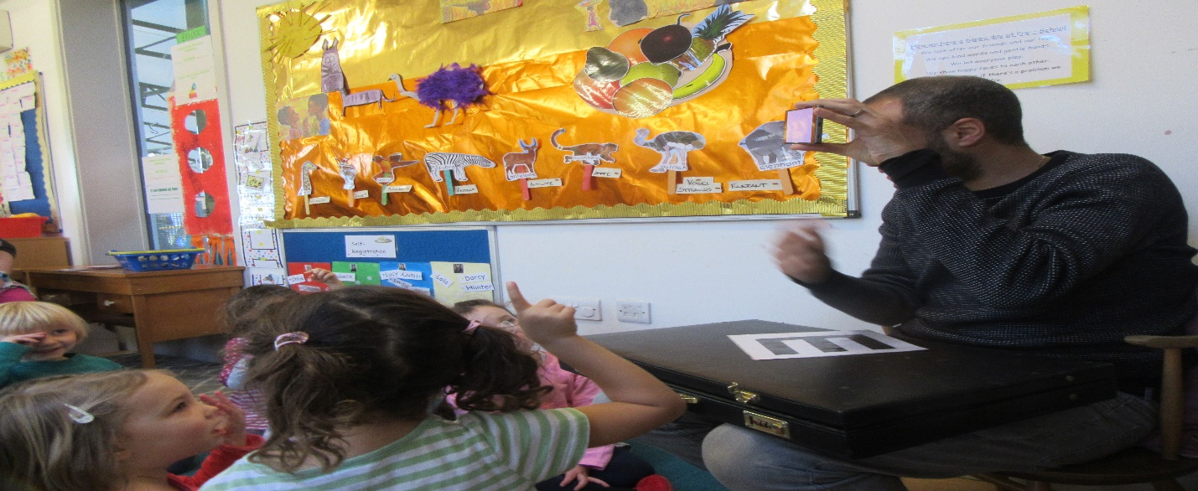
Pre School and the reception class at Streatley Primary school have been having regular visits to each other’s classrooms, this has been so much fun! Streatley Primary school is incredibly supportive to the Pre School and let us use their facilities and join them for ‘the daily mile’.
The phonics evening at the end of January was very informative, staff and parents shared this training, it was delivered by Kirstie Hanson our Early years advisor. Thank you to everyone that attended.
Please continue to send in healthy snacks, we are very grateful for all contributions. Breadsticks, cheese, fresh fruit and vegetables are always popular.
Could I remind parents not to include nuts or peanuts in lunchboxes please, we have an allergy at Pre School and must be strict on this.
We have had a couple of cases of headlice at Pre School, please check your child’s hair. Please see https://www.nhs.uk/conditions/head-lice-and-nits/ Many thanks.
Streatley Hill Pre School is part of ECAT ‘Every child’s a talker’ It is a national strategy to promote the support of language development and communication skills. Please look on our notice board for talking tips or speak to Lisa for further information. http://westberksecat.info/
Safeguarding is everyone’s responsibility, please see myself or Jo if you have any concerns.
Have you heard of EYPP? This stands for Early Years pupil premium and it is extra money that Pres School could claim to benefit your child and the setting, if parents receive certain benefits or are on a low income. Please speak to me in confidence if you believe you may be eligible.
Dates for your diary
World book day | Thursday  7/3/19 | Dress up day
Story teller -Bev from Goring Library will be visiting preschool | Tuesday  19/3/19 @2pm | For children attending this session.
Visit to Coombe house | Wednesday 20/3/19@10.45am | For the children attending this session.
The Great Easter Egg roll!! | Thursday  4/4/19 pm session | All children and their big people welcome. More information to follow.
Easter Holidays | Monday  8/4/19-22/04/19  (Preschool opens 23/04/19) | Pre School closed.
Parents evening | Friday  26/4/19 @6-8pm | At Pre School. More information to follow

Thank you for your continued support,
Kind regards
Cheryl

