Newsletter September 2019
Dear Parents and Carers
A very warm welcome to everyone, I hope you will be very happy at your new Pre School. We are also pleased to welcome Lorna to the staff team, she has joined us as support staff.
I am so grateful for the support and help I receive from our parents and committee, thank you so much to all that have helped already this term and to our new committee, for signing up! I would also like to say a very special ‘thank you’ to Shelley, she has worked so hard and achieved so much for our preschool, as well as being a busy mum to 3 children. I know she is very excited to welcome her new Co-Chair, (more information to follow!) I’m really looking forward to getting to know you all.
There is a new parent helper rota on the front door, please sign up, we would love to fill up as many spaces as possible. It’s a wonderful way to help the preschool and the children love having their big person to visit.
Please let your child’s key person know what your child has been doing at home, we can add their interests into the planning and it is lovely to share achievements and hobbies in their learning journeys. We have a sheet you can use or make your own! Learning journeys are always available to take home and share as a family.
The children are loving their wonderful garden and mud kitchen and have been spending lots of time exploring and playing outside. The children have been busy baking pizza, jam tarts and gingerbread. We have been to the school hall for PE, have had lots of fun doing ‘Dough Disco’ and singing. We have been learning all about ourselves and were we live. Thank you to everyone that sent in a picture of their front door, we have enjoyed sharing these and chatting about them.
The children made a tomato family 😊!!!
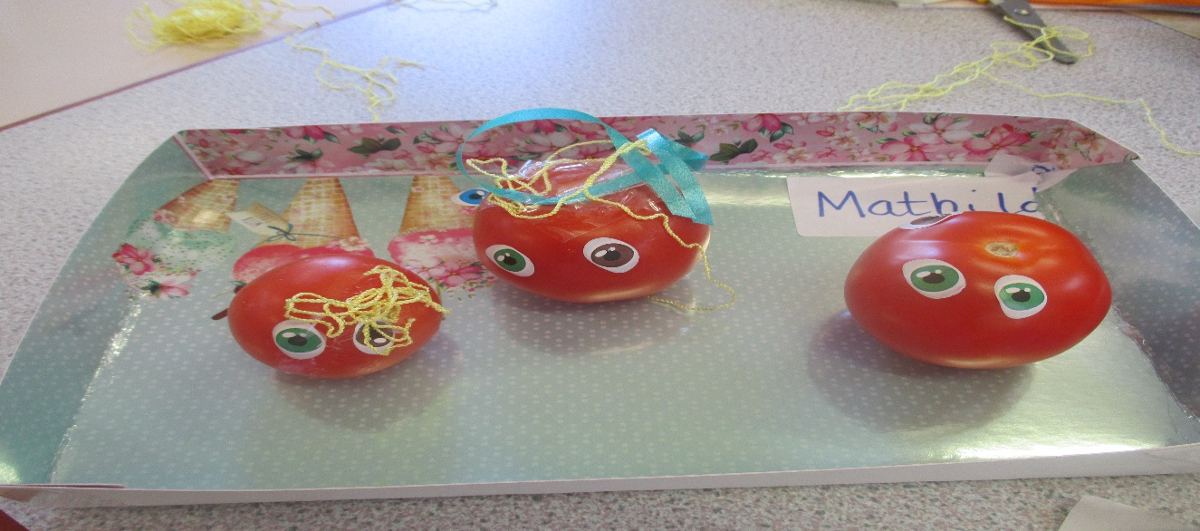
Streatley Primary school is incredibly supportive to the Pre School and let us use their facilities and join them for ‘the daily mile’, the children have really enjoyed this.
Please continue to send in healthy snacks, we are very grateful for all contributions. Breadsticks, cheese, fresh fruit and vegetables are always popular.
Could I remind parents not to include nuts or peanuts in lunchboxes please, we have an allergy at Pre School and must be strict on this.
We have had a couple of cases of headlice at Pre School, please check your child’s hair. Please see https://www.nhs.uk/conditions/head-lice-and-nits/ Many thanks.
Streatley Hill Pre School is part of ECAT ‘Every child’s a talker’ It is a national strategy to promote the support of language development and communication skills. Please look on our notice board for talking tips or speak to Lisa for further information. http://westberksecat.info/
Safeguarding is everyone’s responsibility, please see myself or any member of staff if you have any concerns.
Dates for your diary
Family Christmas photo shoot | Friday 22/11/19 | At preschool during the morning, more info to follow.
Children’s Christmas party | Friday 20/12/19 | All children and their big people invited.11.30 till 1pm, More information to follow
End of term 1 | Friday 20/12/19 | Pre School closed.
Start of term 2 | Monday 06/12/20 | Preschool opens at 9am.

Thank you for your continued support,
Kind regards
Cheryl

